

**Payment Cartridge**

**Test Cases**

***int_checkoutcom***

**Table of Contents**

1. Summary 3

2. Check the order 4

3. Business manager: check the 4

# Introduction

Once the cartridge installed and configured as described in the documentation, you can proceed with a test transaction.

In order to make sure the installation is working as expected, 3 simple steps are required: place an order, check the order, check the transaction.

# Place an order

**Step 1**

Add products into the cart and proceed with the checkout process. Once on the billing page, select the payment option named Checkout.com Credit Card.

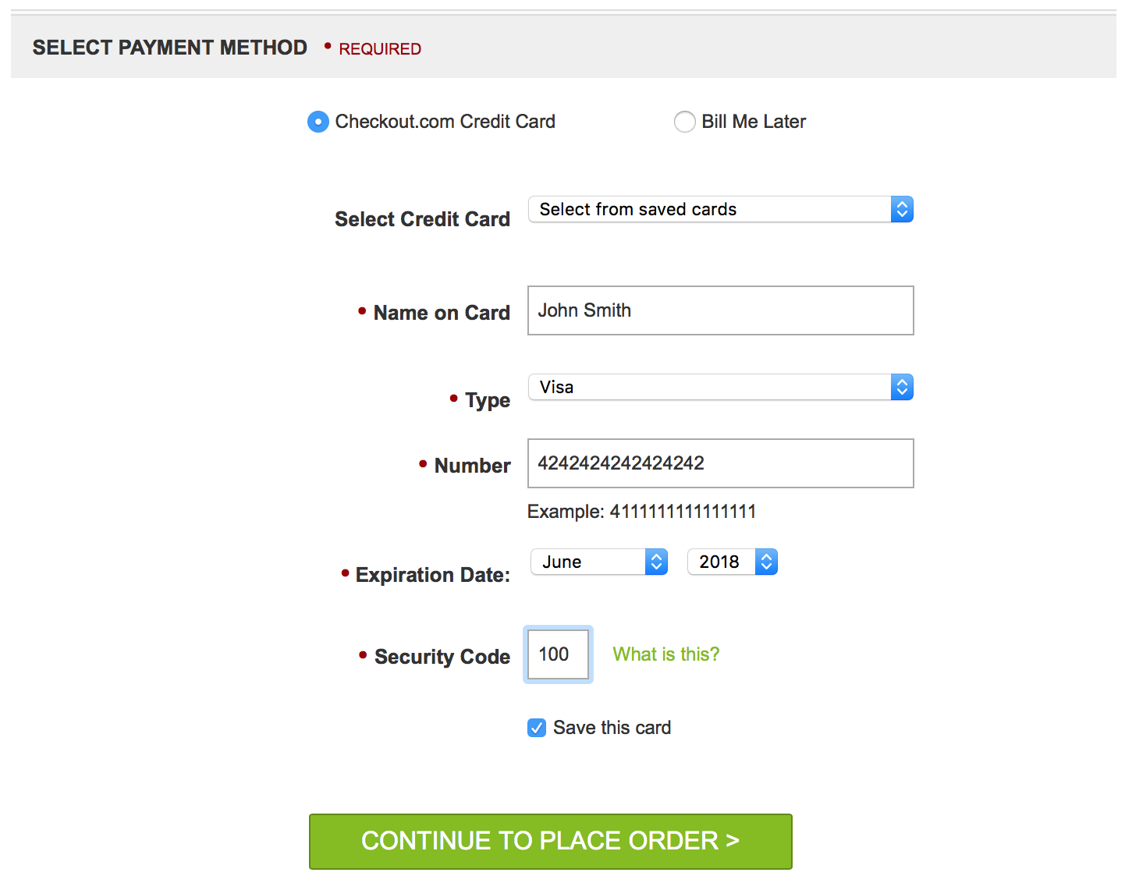

Fill in the credit card form with the following card details:

* Name on card: any
* Type: Visa
* Number: 4242424242424242
* Expiration date: Any date in the future
* Security code: 100

**Step 2**

Proceed to place the order. You will see the order confirmation page after having placed the order.

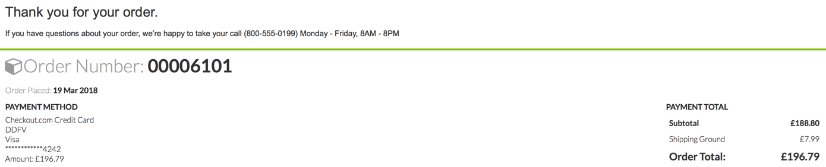

As shown on the left side in the capture above, the order details should contain a reference to the payment method chosen and the card used for the payment, in the PAYMENT METHOD section. In this case:

* Payment method: Checkout.com Credit Card
* Card 4 last digits: 4242

Note the order number so that you can check it in the Business Manager in the next section.

# Check the order

Access the order list in the Business Manager: Merchant Tools > Ordering > Orders

A new order should be available, with an order number corresponding to the one you have placed. Click on it to view the order details.

On the payment tab of the order details, you should find information related to the Checkout.com payment method.

The “Payment Method” section of the tab should contain the following information:

CHECKOUTCOM_CREDIT   
Processor: CHECKOUTCOM_CREDIT   
Transaction: <your_order_id>   
Amount: <amount_of_your_order>

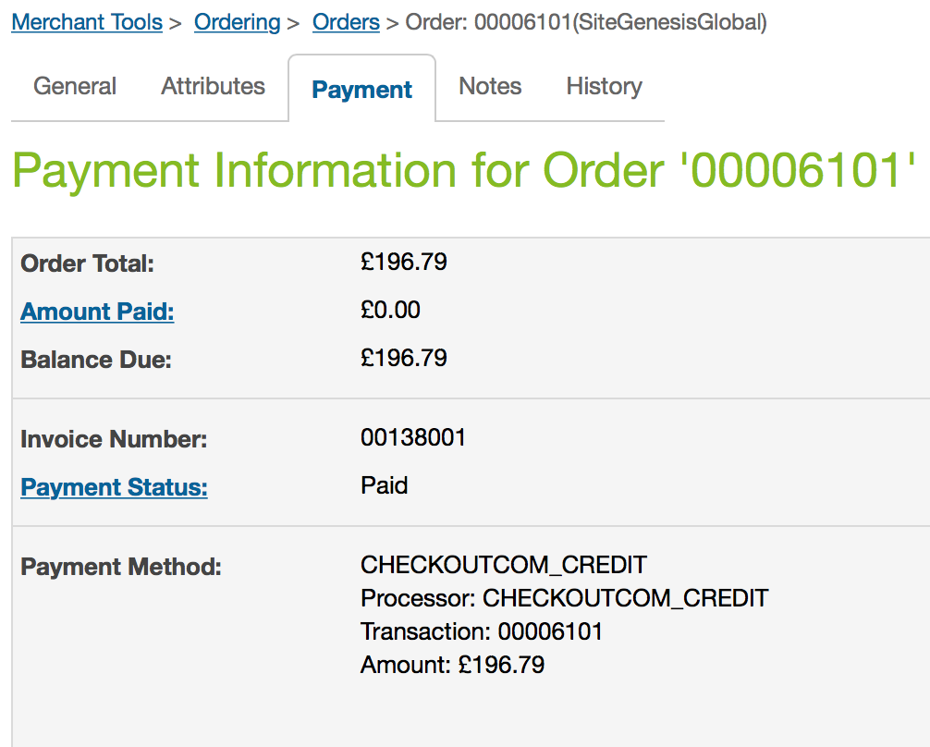

# Check the transaction

The transaction details should be available in the order for a successful payment. In the order details click on the “Notes” tab to view the transaction details.

You should have the details of the transaction, similar to the following:

Checkout.com Customer Id: cust_44593251-A1FD-41A2-9CB4-F1089867CF17

Transaction status: Authorised

Response code: 10000

Response message: Approved

Response advanced info: Approved

Last 4 digits: undefined

Payment method: undefined

Authorization code: 391113

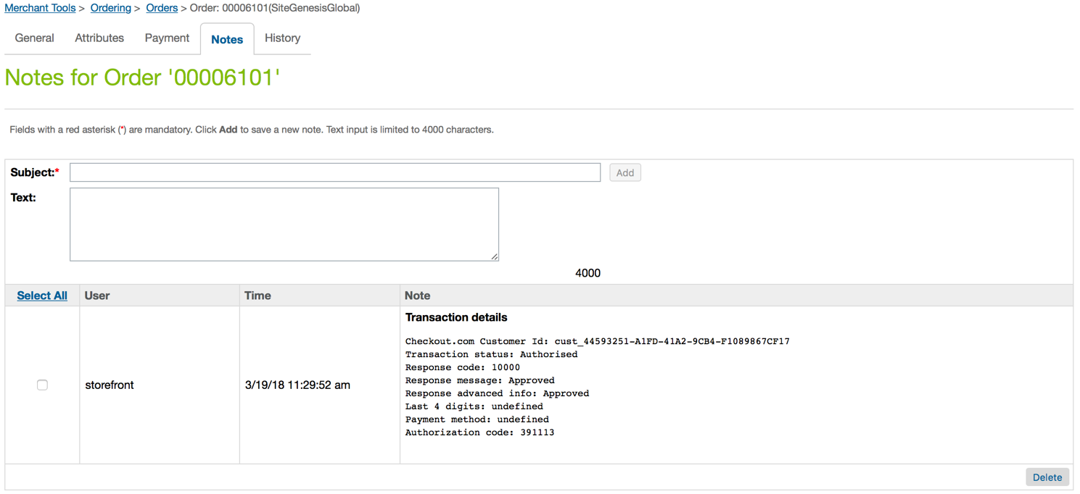

You should have at list one note related to a card authorization, with the response code 10000. This code confirms a successful transaction.

Depending on your cartridge configuration, you may have a second note related to a capture performed on the test card.

With the response code 10000, the cartridge can be considered as working as expected.